PROJECT DESIGN PHASE-II TECHNOLOGY STACK (ARCHITECTURE & STACK)

|  |  |
| --- | --- |
| **DATE** | 23 OCTOBER 2022 |
| **TEAM LEADER NAME** | REEBA SURENDRAN |
| **TEAM NUMBER** | PNT2022MID28963 |
| **TEAM MEMBERS** | NIVETHA SRI K S  SNOWLINE BOMITA R  PRIYA G |
| **PROJECT NAME** | PROJECT – SMART SOLUTION FOR RAILWAYS |
| **MAXIMUM MARKS** | 2 MARKS |

Maximum Marks 4 Marks

**Technical Architecture:**

The Deliverable shall include the architectural diagram as below and the information as per thetable1 & table 2

**Example: Order processing during pandemics for offline mode**

**Reference:** [**https://developer.ibm.com/patterns/ai-powered-backend-system-for-order-**](https://developer.ibm.com/patterns/ai-powered-backend-system-for-order-processing-during-pandemics/)[**processing-during-pandemics/**](https://developer.ibm.com/patterns/ai-powered-backend-system-for-order-processing-during-pandemics/)

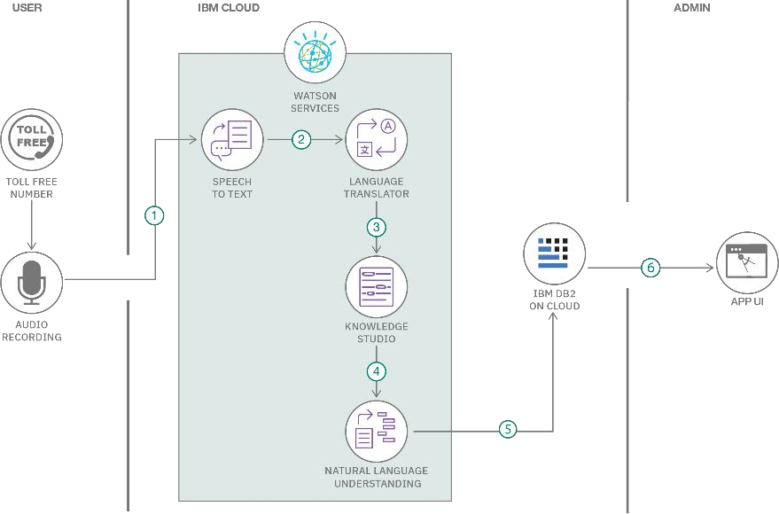

**Table-1 : Components & Technologies:**

|  |  |  |  |
| --- | --- | --- | --- |
| **S.No** | **Component** | **Description** | **Technology** |
| 1. | User Interface | How user interacts with application e.g.  Web UI, Mobile App, Chatbot etc. | HTML, CSS, JavaScript / Angular Js / React Js etc. |
| 2. | Application Logic-1 | Logic for a process in the application | Java / Python |
| 3. | Application Logic-2 | Logic for a process in the  application | IBM Watson STT service |
| 4. | Application Logic-3 | Logic for a process in the  application | IBM Watson Assistant |
| 5. | Database | Data Type, Configurations etc. | MySQL, NoSQL, etc. |
| 6. | Cloud Database | Database Service on Cloud | IBM DB2, IBM Cloudant etc. |

|  |  |  |  |
| --- | --- | --- | --- |
| 7. | File Storage | File storage requirements | IBM Block Storage or  Other Storage Service or Local Filesystem |
| 8. | External API-1 | Purpose of External API used in the application | IBM Weather API, etc. |
| 9. | External API-2 | Purpose of External API used in the application | Aadhar API, etc. |
| 10. | Machine Learning Model | Purpose of Machine Learning Model | Object Recognition Model, etc. |
| 11. | Infrastructure (Server / Cloud) | Application Deployment on Local System / Cloud  Local Server Configuration: Cloud Server Configuration : | Local, Cloud Foundry, Kubernetes, etc. |

**Table-2: Application Characteristics:**

|  |  |  |  |
| --- | --- | --- | --- |
| **S.No** | **Characteristics** | **Description** | **Technology** |
| 1. | Open-Source Frameworks | List the open-source  frameworks used | Technology of  Opensource framework |
| 2. | Security Implementations | List all the security / access controls implemented, use of  firewalls etc. | e.g. SHA-256, Encryptions, IAM  Controls, OWASP etc. |
| 3. | Scalable Architecture | Justify the scalability of architecture (3 – tier, Micro- services) | Technology used |
| 4. | Availability | Justify the availability of application (e.g. use of load  balancers, distributed servers etc.) | Technology used |
| 5. | Performance | Design consideration for the performance of the application (number of requests per sec,  use of Cache, use of CDN’s) etc. | Technology used |

**References:**

[**https://c4model.com/**](https://c4model.com/)

[**https://developer.ibm.com/patterns/online-order-processing-system-during-**](https://developer.ibm.com/patterns/online-order-processing-system-during-pandemic/) **pandemic/** [**https://www.ibm.com/cloud/architecture**](https://www.ibm.com/cloud/architecture)[**https://aws.amazon.com/architecture**](https://aws.amazon.com/architecture)

[**https://medium.com/the-internal-startup/how-to-draw-useful-**](https://medium.com/the-internal-startup/how-to-draw-useful-technical-architecture-diagrams-2d20c9fda90d) **technical-architecture-**[**diagrams-2d20c9fda90d**](https://medium.com/the-internal-startup/how-to-draw-useful-technical-architecture-diagrams-2d20c9fda90d)